**City College Norwich**

**GENDER PAY GAP REPORT**

City College Norwich is required by law to publish an annual gender pay gap report. This report relates to the snapshot date of 31 March 2024. The figures set out in this report have been calculated using the standard methodologies used in the Equality Act 2010 (Gender Pay Gap Information) Regulations 2017.

**Gender Split**

* There were 1,168 paid staff at 31 March 2024.
* 731 were female, 433 male and 4 were other.
* The lowest hourly rate for female staff was £5.28, with a male rate of £6.15 per hour.
* The lowest male rate was a member of student crew in a General Front of House role (16-18 year old). The lowest female rate was for two 16-18 Apprentices.

**Mean Gender Pay Gap**

* **Average (Mean) hourly rate**

Female £16.15

Male £18.33

Gap £2.18

Gap % 11.90

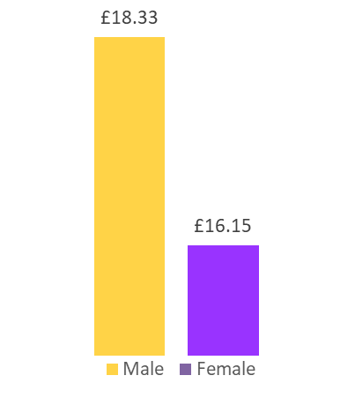

**Median Gender Pay Gap**

**Median Gap**

**17.76%**

**• Median hourly rate**

Female £15.15

Male £18.42

Gap £3.27

**Bonus Gender Pay Gap**

City College Norwich does not pay bonuses to staff.

**Gender Pay Gap Quartiles**

|  |  |  |  |  |  |
| --- | --- | --- | --- | --- | --- |
|  | **CCN 2024** | **CCN 2023** | **Difference in Gap from previous year** | **ONS Average Gap (All employers) 2024** | **ONS Average Gap Education 2024** |
| **Mean** | 11.90% | 7.7% | +4.20 | 13.8% | 12.5% |
| **Median** | 17.76% | 21.5% | -3.74 | 13.1% | 17.2% |

**Underlying reasons for City College Norwich’s Gender Pay Gap**

City College Norwich is committed to the principle of equal opportunities and equal treatment for all employees, regardless of sex, race, religion or belief, age, marriage or civil partnership, pregnancy/maternity, sexual orientation, gender reassignment or disability. City College Norwich pays employees equally for the same or equivalent work, regardless of their sex (or any other characteristic set out above).

The median gap has decreased again by 3.74 from the previous year with the mean gap increasing this year by 4.20. The mean is still 1.9 points below the national (All Employers) figure of 13.8% (source ONS 2024) and below (0.6 points) for the education sector (12.5%). The median is 4.66 points above the national mean of 13.8% and fractionally higher (0.5 points) than the median within our sector (12.5%).

In the year to 31 March 2024, the percentage breakdown for each staff group was as follows:

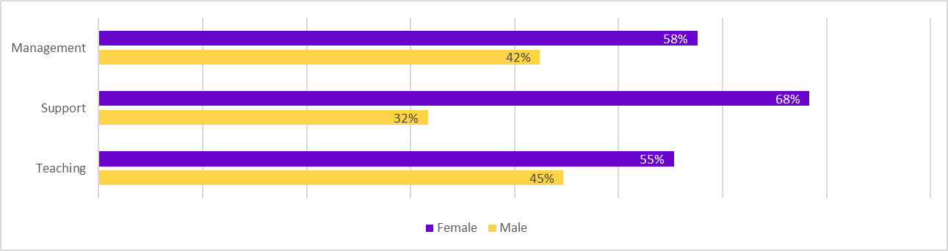

The number of females in managerial roles increased in the last 12 months and now exceeds the number of males. However, the gender pay gap results are predominantly driven by the significant levels of females in support roles (over a third of our workforce) which are lower paid roles. This impacts particularly the median salary outcomes for the College.

Posts in the lower and lower-middle quartiles include Kitchen Assistants, Learning Support Assistants and Nursery Nurses – roles that are often part-time and/or attract mainly female applicants. The College has a large SEND provision, which means there are a large number of Learning Support Assistants providing support to SEND students. In the 12 months to 31 March 2024, 39 females and 10 males applied for these vacancies which are in the lower quartile. 76% of those appointed to these roles were female, which is an increase from the figure of 72% in the previous year.

In the 12 months up to 31 March 2024, 12 of the 17 staff who had internal promotions were female.

As in previous years. the data reflects that the pay gap remains largely due to the choices individuals make to undertake roles which enable them to work flexibly, e.g., term-time only and/or part-time.

For all vacancies in the 12-month period to 31 March 2024, 61% of applicants were female and 63% of those appointed were female. This is an increase from the previous year where 57% of applicants were female and 65% of those appointed were female.

**Actions to address City College Norwich’s Gender Pay Gap**

The College undertakes the following steps to promote gender diversity in all areas of the workforce:

* **Creating an Evidence Base**: To identify any barriers to gender equality and to help us set priorities for action. We currently monitor the following data:
  + the proportion of men and women applying for jobs and being shortlisted and recruited.
  + the proportions of men and women applying for and obtaining internal promotions
  + the proportions of men and women leaving the organisation and reasons for leaving
  + the numbers of men and women in each role and pay band.
  + The College examines the data produced by the surveys completed by starters in their first 3 months of employment and leavers. Feedback is generally in relation to career development and reward and recognition.
  + The College reviews the feedback in exit interviews to identify any issues of equality being reported as reasons for leaving.

Summary information is highlighted in the Annual HR Report that is presented to the City College Norwich Governors.

To ensure consistency, the College additionally monitors:

* + the number of men and women working flexibly and the level within the organisation.
  + the number of men and women who have had applications to work flexibly declined.
* **Recruitment and Selection**
  + The College ensures that interview panels are comprised of the appropriate gender balance that reflects the genders of the candidates being interviewed.
  + The College offers secondment opportunities for some roles, encouraging staff to be developed into senior roles.
  + The College is making greater use of open events to promote its vacancies and the benefits of working at the College. This includes working with the Job Centre to attend days aimed at encouraging candidates with protected characteristics.
  + The College continues to work with Vercida who in addition to advertising the roles, adds features about working at the College in relation to diversity, highlighting areas of good practice.
  + All staff taking part in interview panels are required to undertake training and there is an unconscious bias on-line training module that they can access.
* **Career Progression**
* The College actively supports all staff in career progression and work is currently underway on defining career pathways for particular roles. The College provides and supports opportunities for skills development.
* **Promoting Flexible Working and Family Friendly Policies**
  + Despite the front facing nature of the work within the College, staff continue to have the opportunity to occasionally work from home, as well as to apply to work from home for part of their working week depending on the role they perform. In addition. the College continues to offer a range of flexible working opportunities for staff and applicants, as well as family friendly policies, an on-site nursery and other benefits. These are promoted both on the College’s website and in recruitment information.

The College will continue to monitor its gender pay gap and take action where possible whilst recognising that the gap is due in the main to the roles staff choose to undertake.

I confirm that the information in this statement is accurate.

Hilary Bright

Director of HR Services